Question One

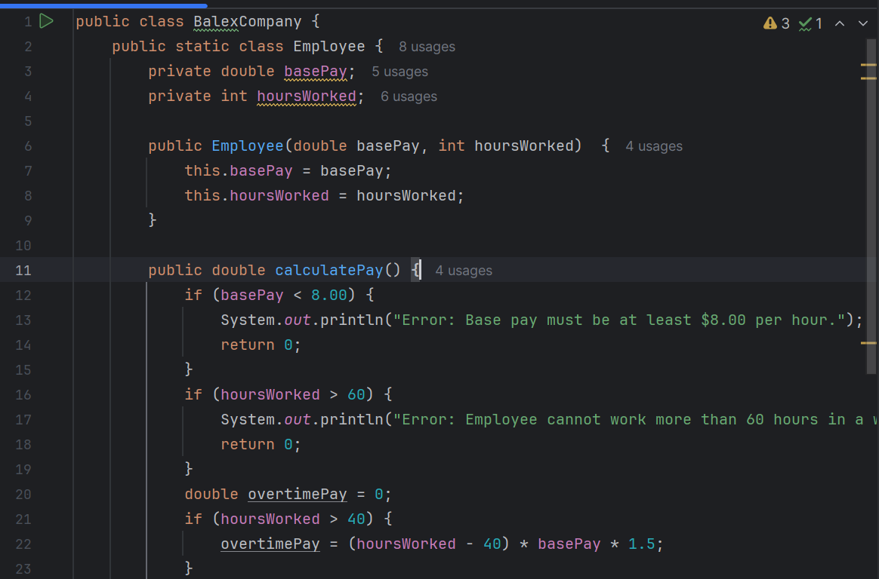

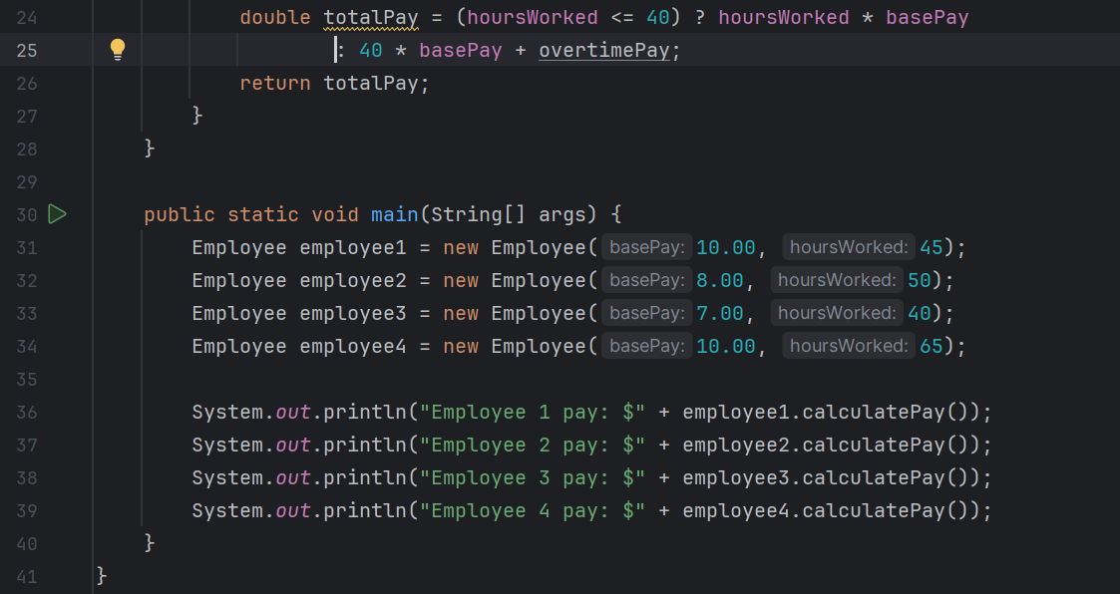

Output

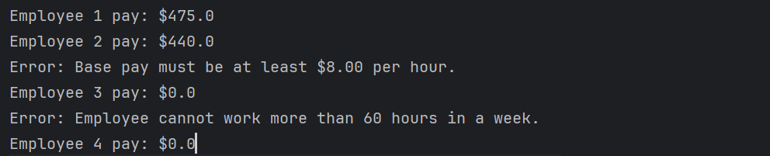

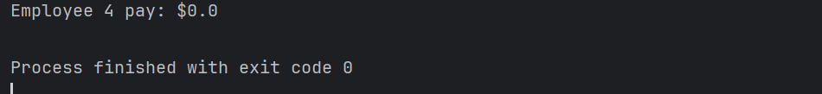

Question Two

Codes

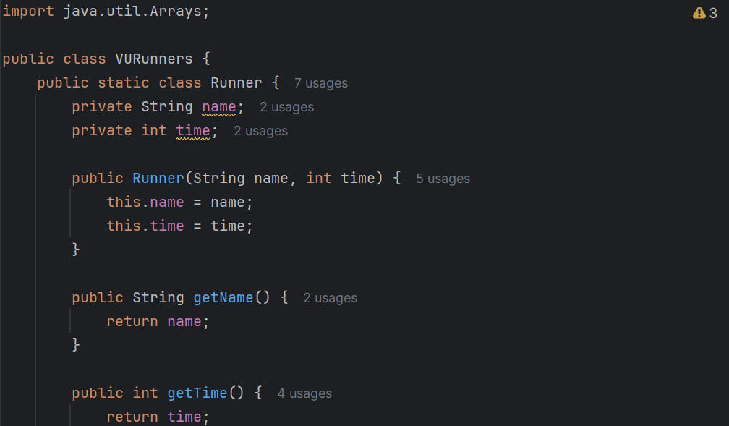

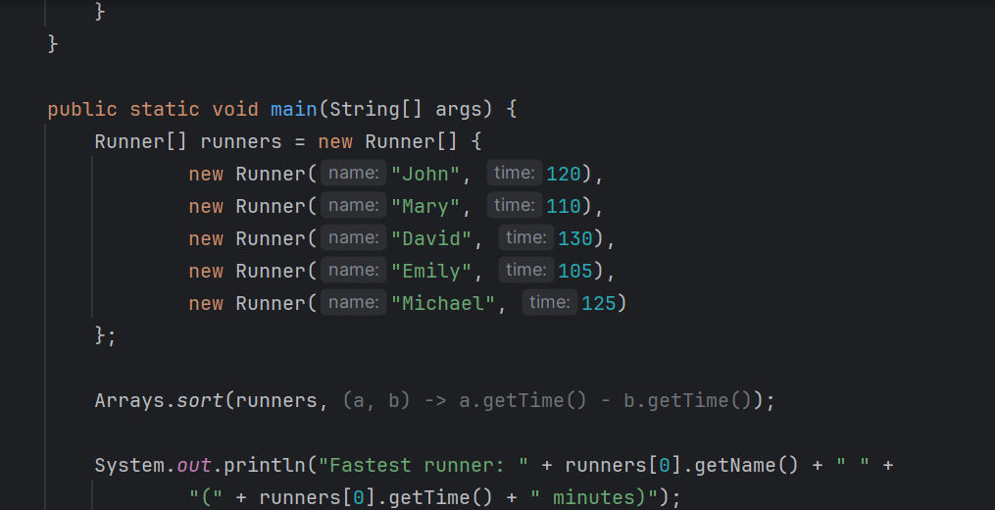

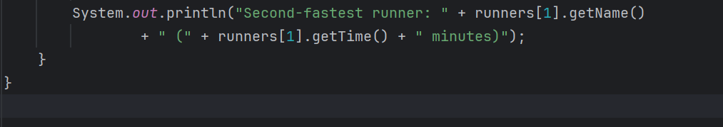

Output



Youtube Links

<https://youtu.be/Po8AtEQxYvw>

<https://youtu.be/Q-b1OXRladU>